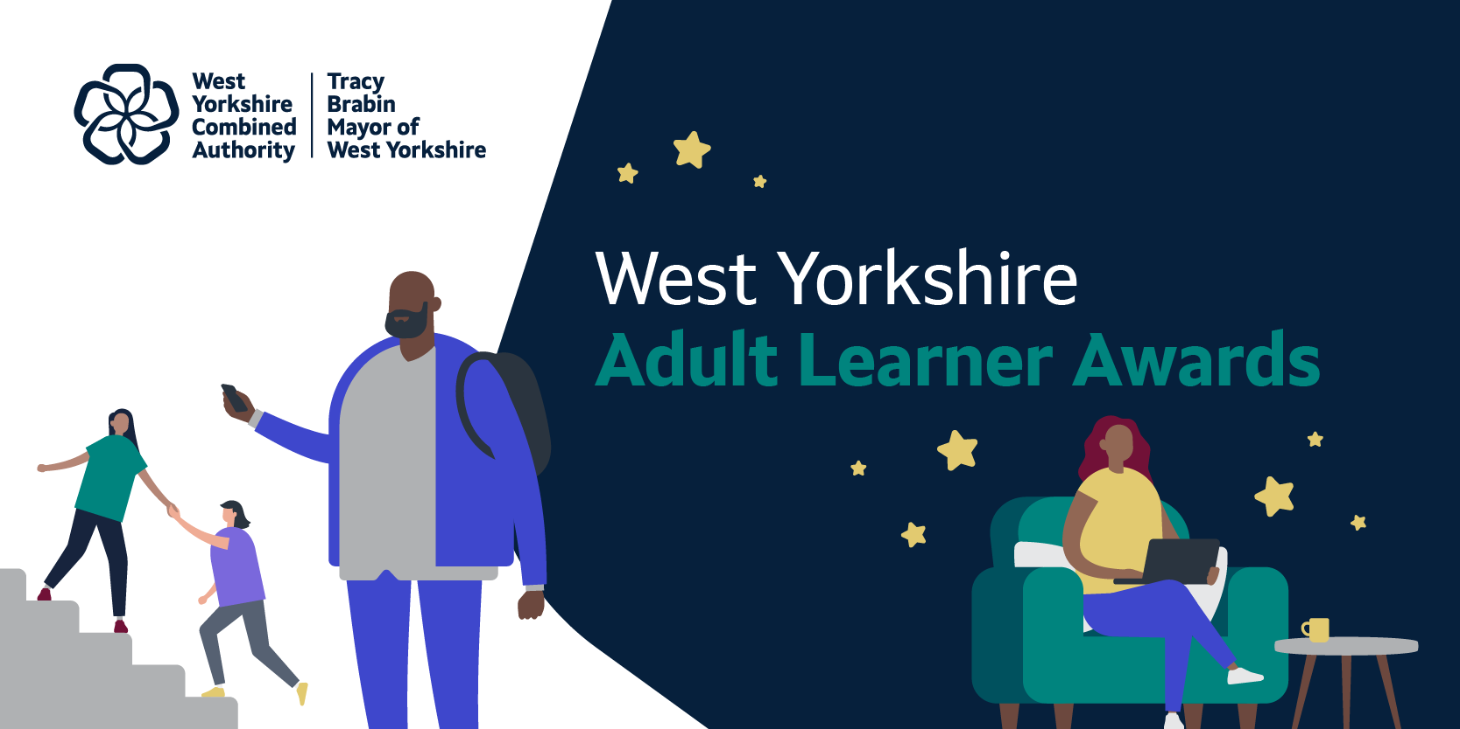

West Yorkshire Adult Learner Awards 2026
Nomination information for providers and employers
We are looking for providers and employers across the region to nominate learners for the 2026 West Yorkshire Adult Learner Awards.
Please share this with colleagues who may have any learners in mind.
All nominations will be reviewed and shortlisted by an impartial panel – deadline for nominations is 5pm Friday 24th July. Winners will be announced at an awards ceremony on Tuesday 3rd November 2026, attended by the Mayor of West Yorkshire.

Who is eligible
Adult learners include anyone who has engaged in adult learning since 1 August 2022, including West Yorkshire Combined Authority and UKSPF-funded provision (Adult Skills Fund, Tailored Learning, Free Courses for Jobs, Skills Connect, Skills Bootcamps, Gainshare and Multiply) and higher education courses across West Yorkshire.
Nominees must be a resident of West Yorkshire and aged 19 or over when they started their course. Learning may have been delivered through a local authority, college, university, voluntary sector organisation or independent training provider.

What the panel is looking for
This year, the panel will score nominations based on the impact of the learner’s skills development. We want to recognise what funded adult learning actually delivers for people in West Yorkshire.
Strong nominations clearly show:
- where the learner started (skills, qualifications, employment or life situation before the course)
- which course or courses they took and which provider delivered them
- which funded provision supported their journey (for example Adult Skills Fund, Skills Bootcamps, Free Courses for Jobs, Multiply, Tailored Learning, Skills Connect or higher education)
- what they have learned (specific skills, qualifications or knowledge gained)
- what they have done with their learning (new job, progression to a higher level, supporting family or community, starting a business, volunteering, applying skills in life)
- why they stand out from other learners

Tips for writing a strong nomination
- Name the course or courses clearly, including the level and the provider.
- Name the funded provision (Adult Skills Fund, Skills Bootcamp, Free Courses for Jobs, Multiply, Tailored Learning, Skills Connect, Gainshare or higher education).
- Be specific about skills gained,
- Include outcomes where possible: qualifications achieved, jobs secured, progression to a higher level, businesses started, voluntary roles taken on.
- Choose the single category that best fits the learner rather than ticking several. If you genuinely think two categories apply, mark one as primary.
- Keep the statement focused. The panel reads many nominations and a clear, well-structured statement stands out.

Award categories

Inspirational Adult Learner
To be awarded to a learner who has shown outstanding progress and impact through their adult learning. Strong nominees will demonstrate clear progression in their skills or qualifications, often across several levels or aims, and the tangible difference their learning has made in their work, family, community or wider life. Personal dedication and resilience are part of the picture, but the panel is looking for clear evidence that the learning has made a real difference.

Higher Education Learner Award
To be awarded to a student who has taken part or is taking part in a higher education or access to higher education course in West Yorkshire and has shown fantastic progress and/or commitment to their learning. They may have taken on additional responsibilities within their institution, for example setting up a society, study group, taken part in volunteering, peer mentoring or impressed their tutor with their progress.

Step into Learning Award
To be awarded to a learner who has taken their first steps into adult education through tailored learning, entry-level provision or Level 1 courses.This could be a learner who has impressed their tutor(s) with their resilience, motivation and commitment . The panel is particularly interested in learners who have re-entered education after a long absence or after a negative earlier experience of education.

Learning for Work Award
To be awarded to a learner who has used adult skills training to enter, progress in, or take their first steps towards employment. Strong nominees will clearly show three things:
- where they started (qualifications, employment status, skills gaps or barriers to work)
- the specific skills or qualifications they gained through the course
- the tangible outcome (new job, promotion, apprenticeship secured, hours increased, self-employment, or becoming work-ready and actively job-searching with confidence)
Nominations for this award can come from training providers, employers, apprenticeship coaches or progression staff.

English Language Learner Award
To be awarded to a learner who has taken part in one or more English for Speakers of Other Languages (ESOL) courses at any level. Strong nominees will be making significant progress through ESOL levels and using their improving English to take a more active role in their family, community or workplace. The panel wants to see how language skills are being applied in practice, whether that is supporting children with school, navigating services, gaining employment, progressing into further training, or contributing to the community.

Breaking Barriers Award
To be awarded to a learner who has overcome or navigated barriers and made great progress through their adult education and acts as an advocate of lifelong learning. They may have entered and succeeded in a sector where they are typically a minority group or acted as a role model to others to support a more diverse workforce.

Lifelong Learning Award
To be awarded to a learner who has used adult learning to make a significant career change. This might be moving into a completely new sector, returning to work after a long break, pivoting after redundancy or, or stepping out of a job that no longer suited them into one that does.
Strong nominees will show their previous employment situation, the specific course or qualification that enabled the change, and the new role they have secured or are actively working towards. This award celebrates the power of funded skills training to open new doors at any stage of working life. Nominations can come from training providers, employers or career coaches.

Giving Back Award
To be awarded to a learner who has used their adult learning experience to create social impact or to champion lifelong learning to others. Strong nominees will clearly link the skills they have developed to how they are giving back. Examples include volunteering as a learning champion, peer mentoring on courses, using interpreting or teaching skills to support others, setting up a community group or social enterprise, or running a business with a clear community focus.

How to submit a nomination
Nominations are submitted through our online form
The deadline for nominations is 5pm Friday 24th July.

With thanks to all the adult learning providers across West Yorkshire who support the organisation and delivery of this event

Find out more
westyorks-ca.gov.uk
West Yorkshire Combined Authority
Wellington House
40-50 Wellington Street
Leeds
LS1 2DE

All information correct at time of writing

